- Telecom Customer Churn Prediction

MY SQL
Table creation in mysql :
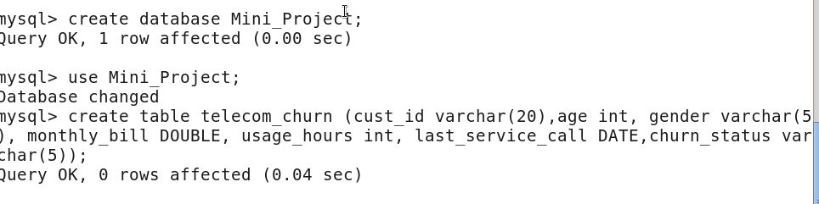
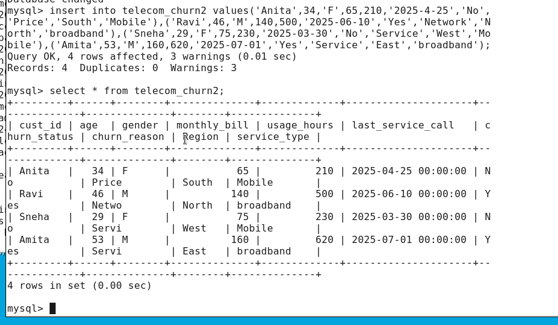

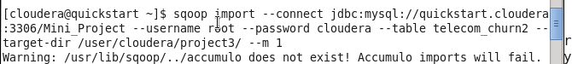

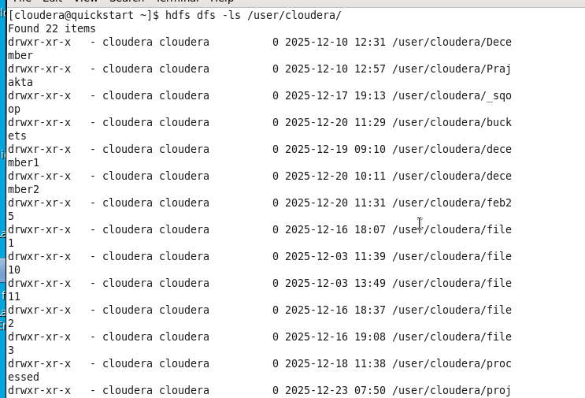
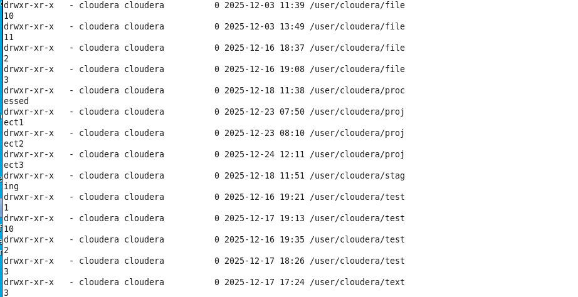

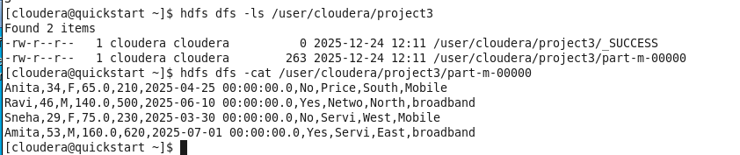

Ques 1 : Identify customers who churned in the last 90 days based on Last_Service_Call and Churn_Status = 'Yes'.

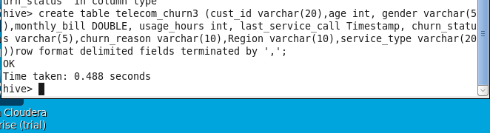

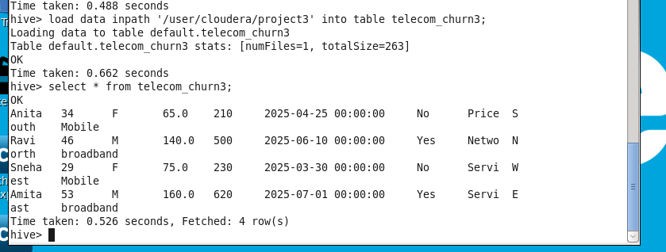
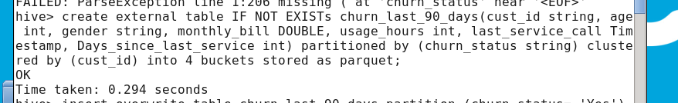
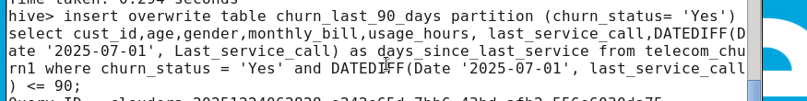
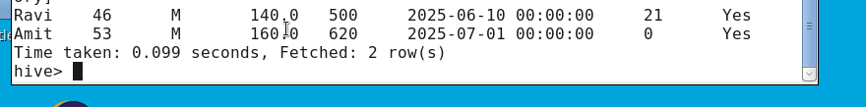

Ques : 2 Calculate and compare the average Usage_Hours between churned and retained customers.
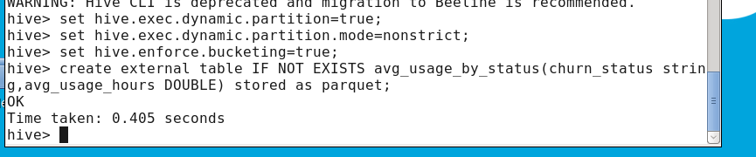
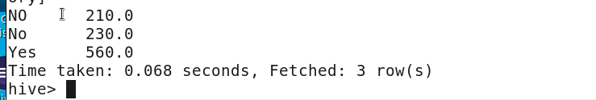
Ques 3 : Analyze the relationship between Monthly_Bill and churn status — do higher bills correlate with higher churn?

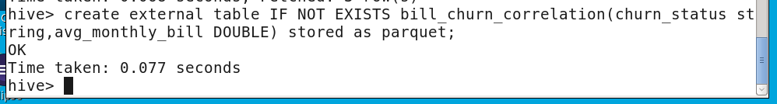
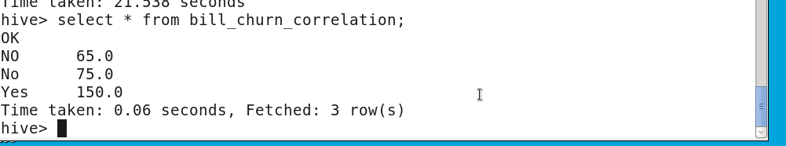

Ques : 4 Track the distribution of days since the last service call for churned customers to detect support-related churn risk.

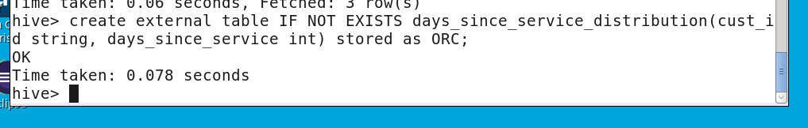
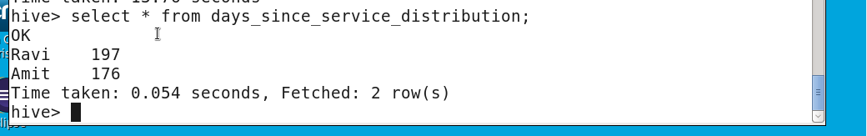

QUES : 5 Build churn risk indicators using Usage_Hours and Monthly_Bill thresholds (e.g., high usage + high bill = risk).

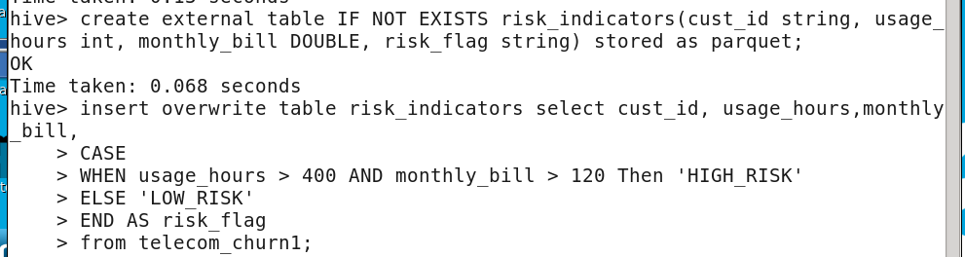
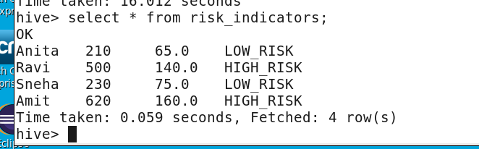

Ques : 6 Use historical data to train a churn classification model in a downstream ML pipeline (outside Hive scope).

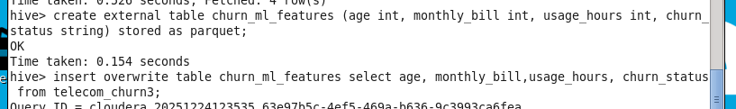

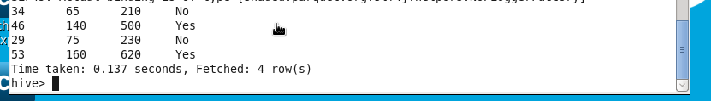

Ques : 7 Extend the dataset to include a Churn_Reason column and list the top 3 most common churn reasons.

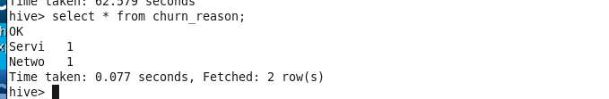

Ques : 8 Group churn data by Age buckets and Gender to find patterns in customer demographics.

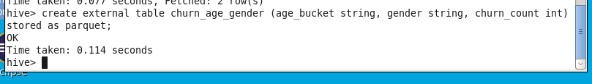

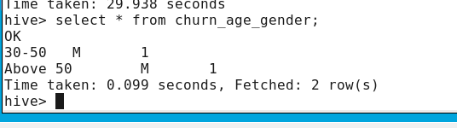

Ques : 9 If available, include a Region field and analyze churn rates by geographic region.

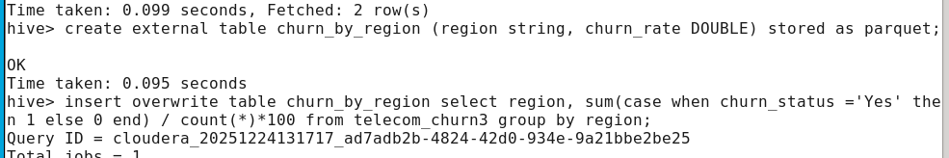

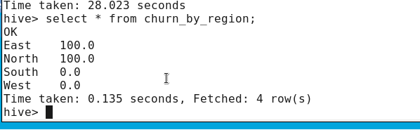

Ques : 10 Identify high churn-risk customers based on similar usage and billing patterns to those who have already churned.

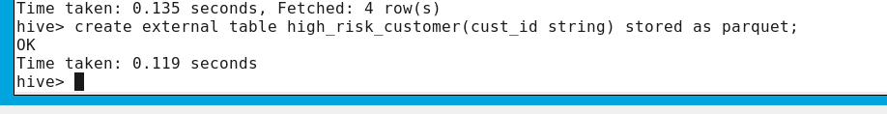

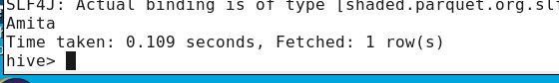

Ques : 11 Write a Shell script to automate extraction of telecom churn data from MySQL and place it in HDFS.

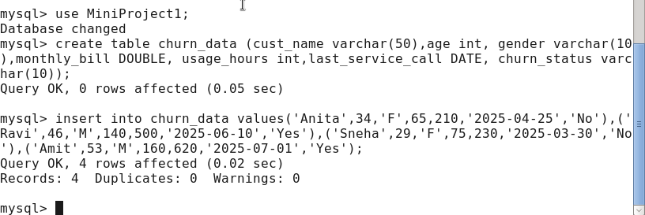

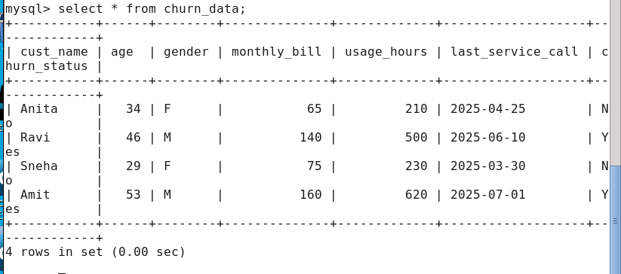

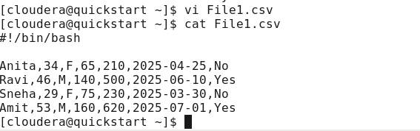

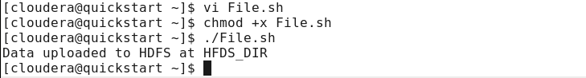

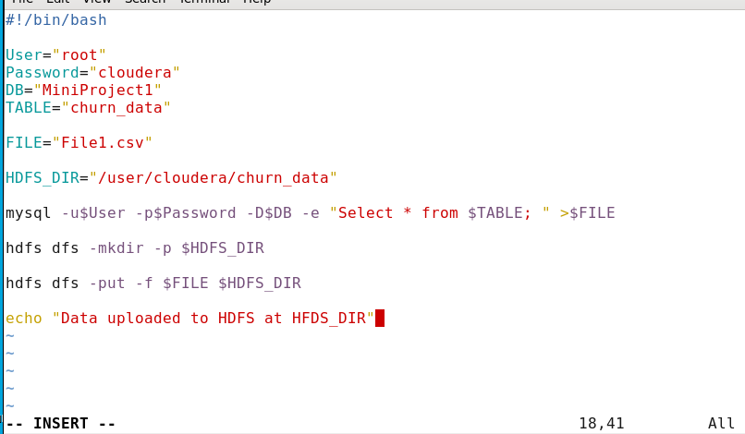

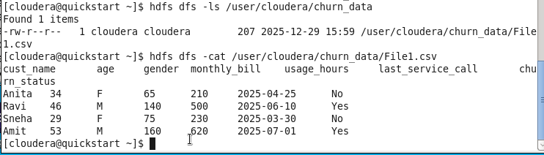
Ques : 12 Create a Hive external table partitioned by month(Last_Service_Call) to manage churn data efficiently.

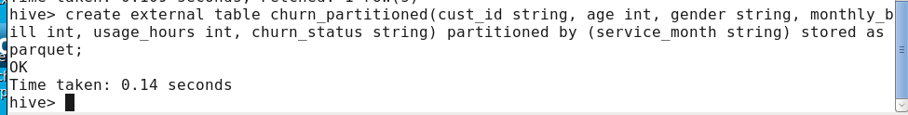
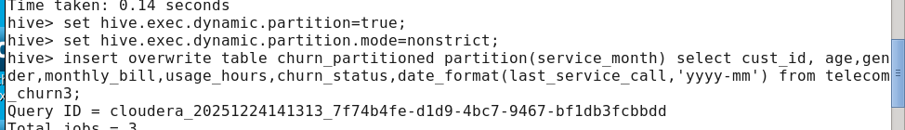

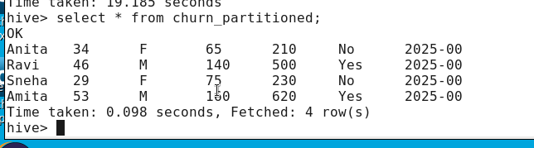

Ques : 13 Use Sqoop to import customer churn and usage data from MySQL to Hive, filtering for the current year only.
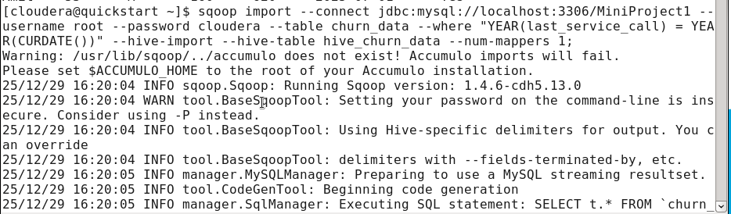
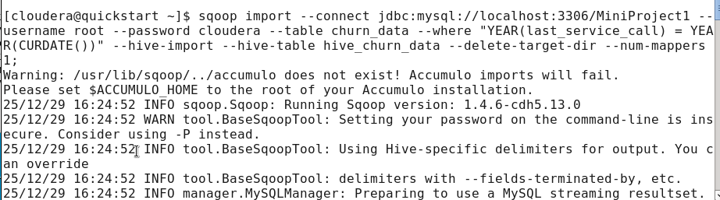
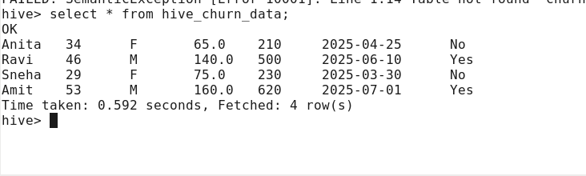

Ques : 14 Extend your dataset with a Service_Type column and compare churn rates across services (e.g., mobile vs. broadband).

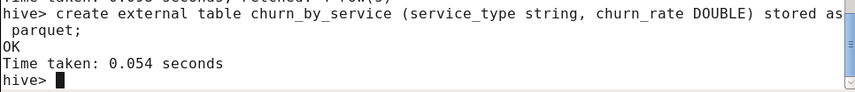
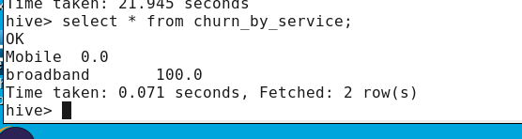

Ques : 15 Validate churn data integrity by checking for nulls, invalid ages, or negative bills before ingesting into Hive.

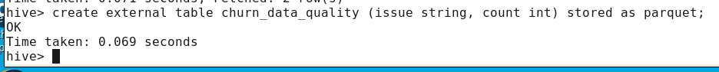

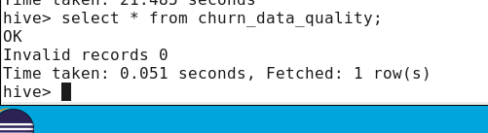

Retail Customer Loyalty Program Analysis

HDFS HIVE
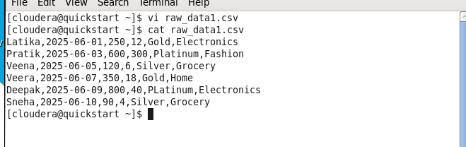

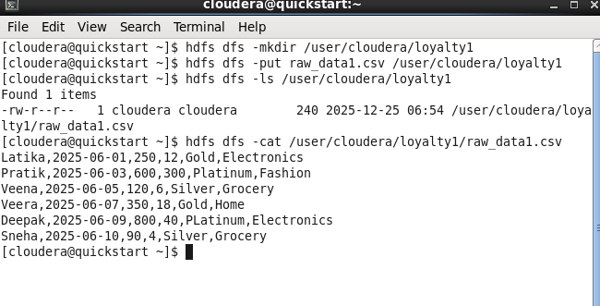

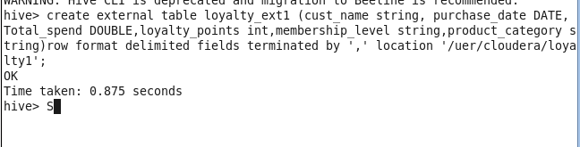

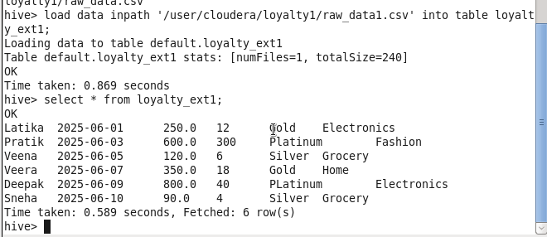

Ques : 1 Calculate the total loyalty points earned by each customer.

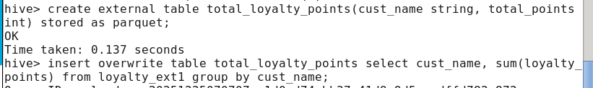

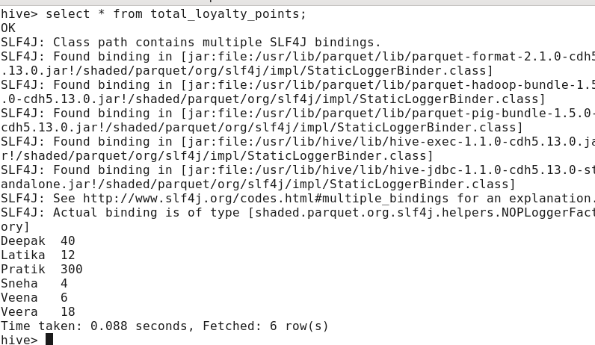

2. List the top 3 customers with the highest loyalty points earned in the last 3 months.

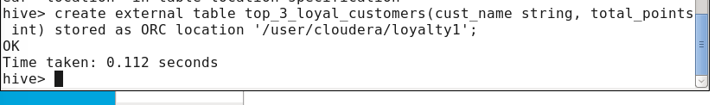

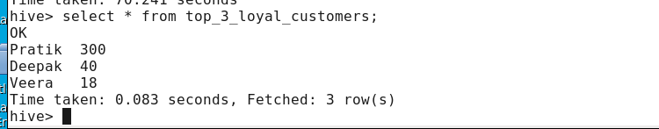

3. Compare total spend across different membership levels (Silver, Gold, Platinum).

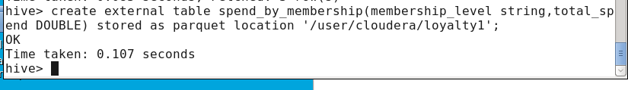

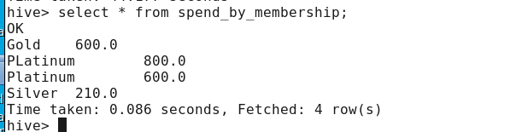

4. Identify customers who are close to reaching the threshold for the next membership level (e.g., Silver to Gold, Gold to Platinum).

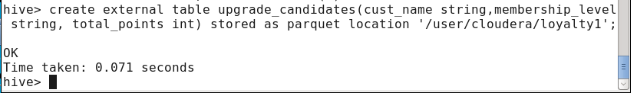
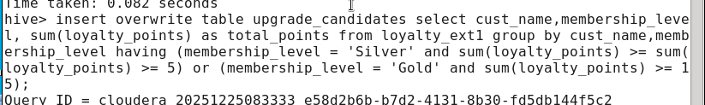

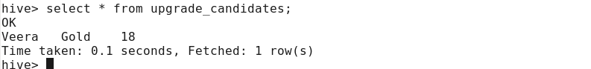

5. Aggregate total spend by membership level.

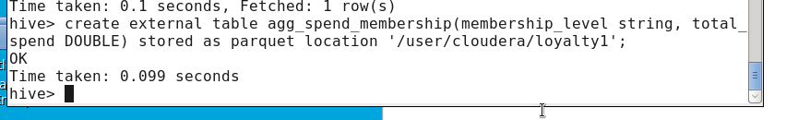

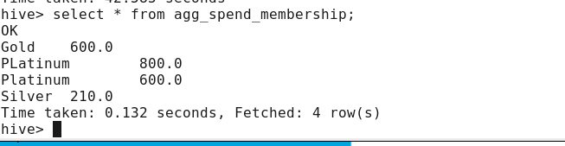

6. (Optional: if product data is joined) Identify top product categories purchased by loyalty program members.

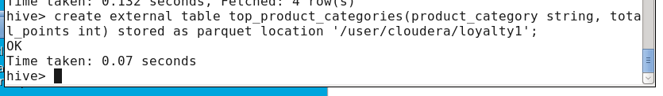
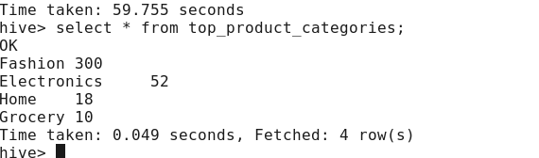

7. (If historical data is available) Track changes in spending behavior after joining the loyalty program.

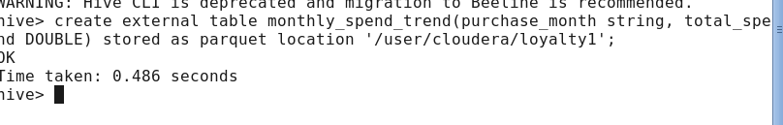
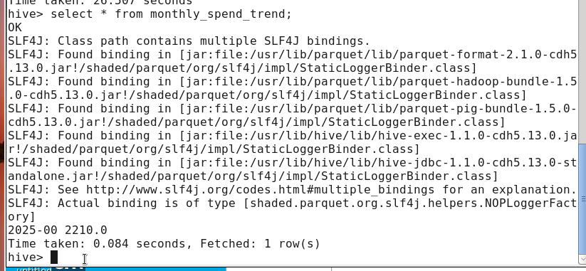

8. (If comparison data is available) Compare purchase frequency between loyalty members and non-members.

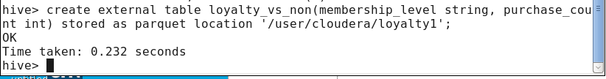

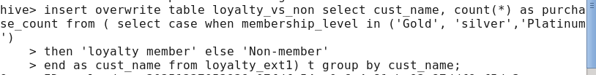

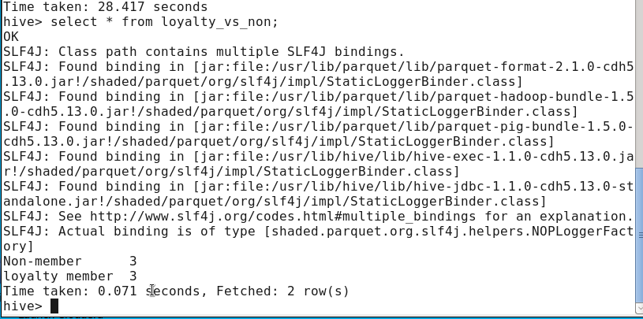

9. Generate a report showing loyalty points accumulation and estimated redemption value.

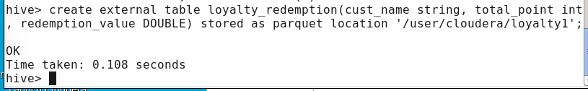

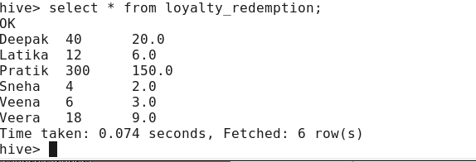

10. (If product categories are linked) Aggregate loyalty points by product category to find popular rewards drivers.

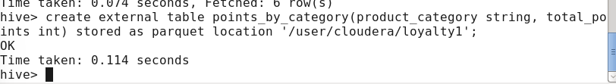

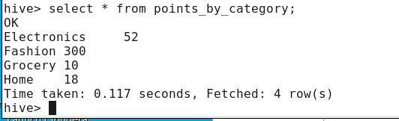

11. Write a Shell script to automate loyalty program data extraction and store it in HDFS.

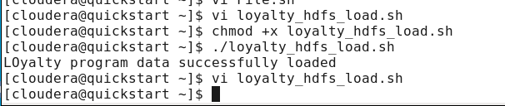

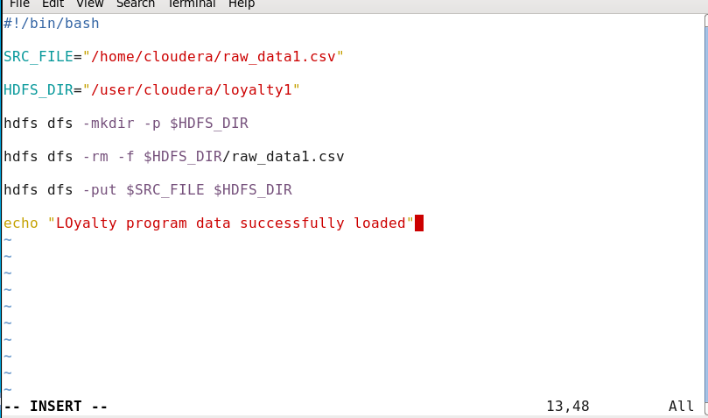

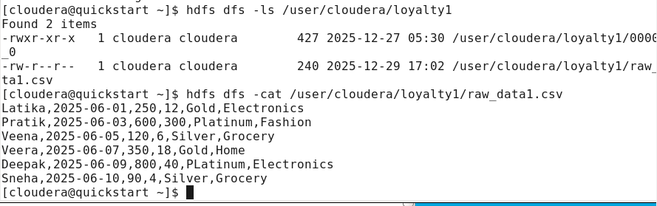

12. Join loyalty program data with customer demographics to analyze trends by age/gender.

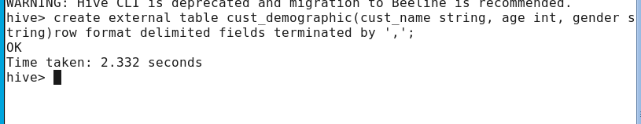

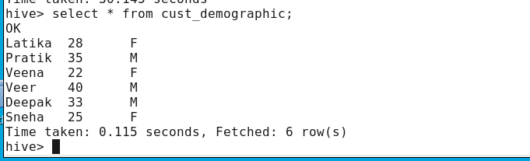
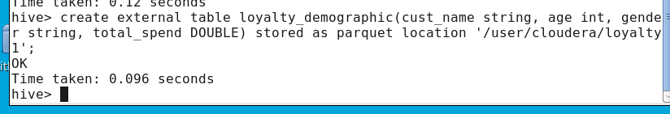
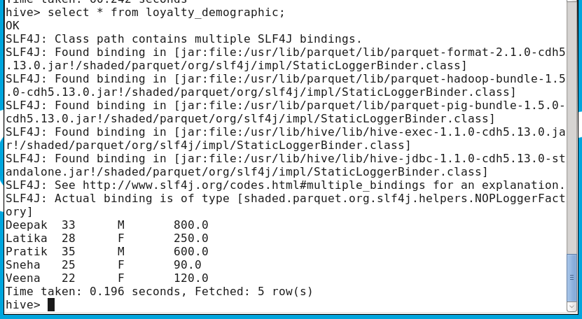

13. Use Sqoop to import loyalty data from MySQL into Hive for analytics.
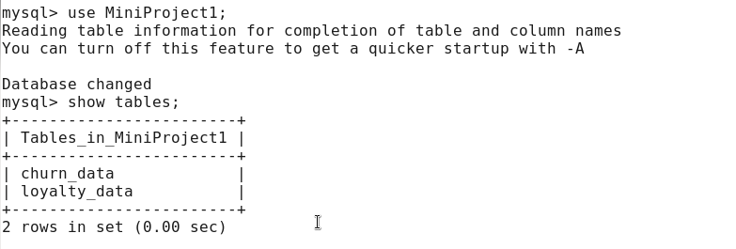
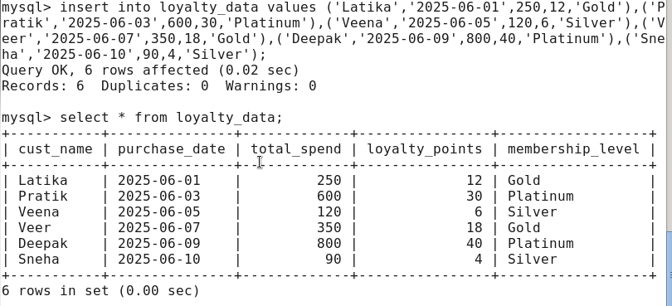

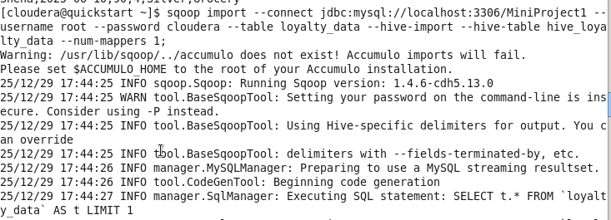
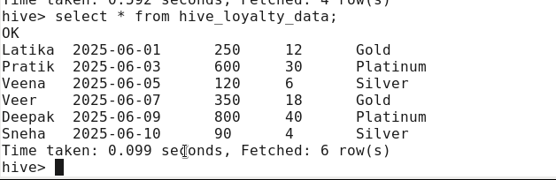

14. Analyze the impact of recent promotions on member spending and point earning.

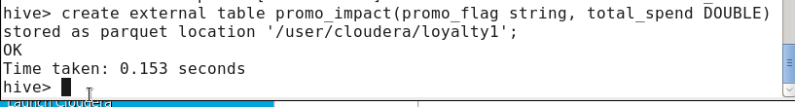

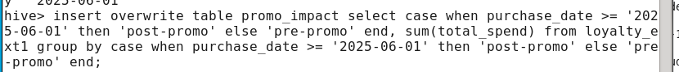

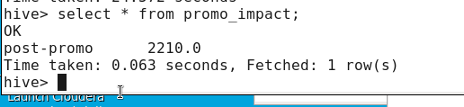

15. Track membership retention rates by level (Silver, Gold, Platinum) over the last year.





